Samantha Howley
The River Corridor Provides Crucial Carbon Storage in North Florida’s Flatwoods.

The River Corridor Provides Crucial Carbon Storage in North Florida’s Flatwoods.

Summary:
The river corridor (RC)- the stream, hyporheic zone, and riparian wetland- is believed to play a crucial role in lateral carbon (C) exchange between terrestrial uplands and streams, yet it remains understudied and often overlooked in carbon budgeting models. This project aims to investigate the influence of the RC on stream C dynamics within flatwood landscapes, and across confined and unconfined aquifer watersheds. I hypothesize that the RC is a tremendous source of stream C, with greater wetland coverage basins exhibiting higher RC carbon storage potential due to elevated water tables facilitating lateral subsurface transport. By exploring RC carbon transport across different watershed types, the study aims to enhance understanding of the C budget in flatwood landscapes and interrogate C transport mechanisms. Through observations of streams and intermittently connected wetlands across varying wetland coverage gradients, this study seeks to shed light on the often-overlooked role of RC and riparian wetlands in watershed C dynamics.
Introduction:
The river corridor (RC)- the stream, hyporheic zone, and riparian wetland- is hypothesized to have a crucial role in lateral carbon (C) exchange between the terrestrial uplands and streams. However, the RC has not been thoroughly investigated and is often overlooked in C budgeting models. For this project, I aim to investigate the influence of the river corridor (RC) on stream C within flatwood landscapes and identify the RC's role in stream C fluxes across both confined and unconfined aquifer watersheds. I hypothesize that the RC sources the majority of stream C and serves as a significant C stock. Additionally, RCs belonging to basins with greater wetland area will exhibit higher C storage potential due to raised water tables supporting lateral subsurface transport. I seek to expand the understanding of the C budget within flatwood landscapes and provide insights into C transport mechanisms within different watershed types.
Background:
Inland waters- streams and wetlands- play a crucial role in the global carbon (C) budget, functioning as the primary drainage network for their respective watersheds (Cole et al., 2007; Drake et al., 2018; Raymond et al., 2013). Stream C is predominantly allochthonous, originating from upland sources, with only a minor portion being internally produced (Battin et al., 2009; Regnier et al., 2022). Despite being widely acknowledged as a C source, streams emit more carbon dioxide (CO2) than can be explained by stream metabolism alone (Cole et al., 2007; Raymond et al., 2013). Conversely, wetlands are commonly regarded as C sinks. Owing to their hydric soils, wetlands accumulate organic matter (OM) within their sediments, resulting in the formation of thick layers of humic material that offset greenhouse gas emissions (Mitsch et al., 2013; Raymond et al., 2013; Vlek, 2014). In addition to C storage, wetland areas are positively associated with water table depth, serving as watershed-scale buffers against drought, and act as reservoirs for nutrients, which can subsequently be circulated throughout the watershed via subsurface or overland flow pathways (Evenson et al., 2018; Li et al., 2023; McLaughlin et al., 2014). Wetlands and streams are intricately connected, forming a complex, dual-pathway C transport (and nutrient) network (Leibowitz et al., 2018), with wetlands acting as stream headwaters and catchments, and streams facilitating connectivity between wetlands through overland and subsurface flows (Abril & Borges, 2019; Casson et al., 2019; Li et al., 2023; Moustapha et al., 2022).
Current global C-budget models estimate that of the 4.5 Pg-C/year produced by the terrestrial landscape, 3.4 Pg-C/year is delivered to streams (Regnier et al., 2022). Utilizing mass counting of stream CO2 emissions, it is found that of the 3.4 Pg-C/year, 0.6 Pg-C/year is buried in sediment, 0.3 Pg-C/year is photosynthesized, and 0.95 Pg-C/year is transported to oceans, leaving a significant 1.5 Pg-C/year gap (Battin et al., 2009; Drake et al., 2018; Kirk & Cohen, 2023; Regnier et al., 2022)This gap is assumed to be CO2 degassing from groundwater seepage (FIGURE 1) (Hotchkiss et al., 2015). However, wetlands, recognized as global C sinks, are often omitted from global estimates, and their contributions to stream C remain unclear (Harvey & Gooseff, 2015; Kirk & Cohen, 2023; Leibowitz et al., 2018; Vázquez et al., 2007). Wetlands are challenging to delineate at the global scale; wetlands are not terrestrial nor are they always aquatic, potentially drying outside of the wet season and thus, are frequently excluded from global C budget assessments (Raymond et al., 2013; Vlek, 2014). Nonetheless, due to the accumulation of OM in their hydric soils, wetlands have the potential to act as 'carbon pumps,' delivering significant volumes of C to streams (Abril & Borges, 2019; Mitsch et al., 2013). This oversight could lead to an overestimation of the influence of global groundwater while largely overlooking the contribution of wetlands.
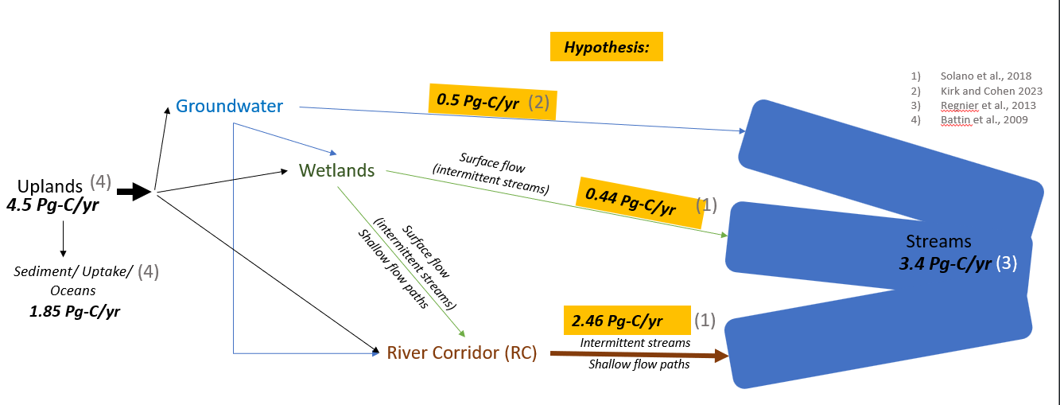
FIGURE 1. Hypothesized carbon budget extrapolated from Solano et al., 2018, Kirk and Cohen 2023, Regnier et al., 2013, and Battin et al., 2009. Over 75% of terrestrial carbon is fated to enter steams through various pathways, dependent on the landscape.
At the watershed scale, studies investigating wetland C-fluxes to streams often overlook riparian wetlands, instead focusing solely on isolated or intermittently connected wetlands (those linked to streams by overland flow during periods of high discharge) (e.g. Casson et al., 2019; Hosen et al., 2018; Moustapha et al., 2022; Solano et al., 2024). Riparian wetlands, essentially stream floodplains, represent the transitional zone between terrestrial uplands and streams. Like other wetlands, they are susceptible to flooding, possess hydric soils, and host hydrophilic vegetation. Riparian wetlands can exert a disproportionate influence on stream chemistry because all particulates and nutrients must pass through them, typically via subsurface flow, before reaching streams (Kirk & Cohen, 2023; Wohl et al., 2017). Consequently, riparian wetlands harbor significant potential for C storage and could serve as dominant C sources for streams (Ledesma et al., 2015), particularly if the landscape trends towards subsurface lateral flow as opposed to longitudinal overland flow from upland sources (Harvey & Gooseff, 2015; Kirk & Cohen, 2023). Despite their importance, riparian wetlands are challenging to distinguish from terrestrial uplands, especially during baseflow, and are frequently neglected in research endeavors.
The zone of lateral exchange between streams and adjacent riparian wetlands is commonly referred to as the river corridor (RC), encompassing the stream, the hyporheic zone, and the riparian wetland, from water table to canopy (Harvey & Gooseff, 2015; Kirk & Cohen, 2023). The RC is hypothesized to contain disproportionately high concentrations of both inorganic carbon (IC) and organic carbon (OC), in gaseous and particulate phases, as it serves as the primary pathway for lateral carbon exchange between terrestrial uplands and streams (Kirk, 2023; Ledesma et al., 2015, 2018). In boreal forests, studies have shown that up to 90% of stream dissolved organic carbon (DOC) is derived from the RC, which maintains a long-lasting supply of DOC with a theoretical turnover time of hundreds of years (Ledesma et al., 2015, 2018). For instance, Kirk and Cohen (2023) found that 86% of the lower Santa Fe River's CO2 originated from its RC, with only 14% sourced from groundwater seepage. In contrast, isolated and intermittently connected wetlands contribute a relatively minor 15% of carbon to stream C.
An ecosystem garnering increasing interest for its capacity to store C is the flatwoods of North Florida. Predominantly managed for pine stands, North Florida's flatwoods feature low relief terrain dotted with numerous wetland depressions. The dense coverage of wetlands in the flatwoods, coupled with the presence of the Hawthorne Formation, supports a shallow, near-surface water table. In the flatwoods, deep groundwater seepage from the Upper Floridian Aquifer (UFA) is minimal, and the flux of C to streams is primarily driven by lateral transport via the shallow water table, emphasizing the importance of the river corridor (RC). This hydrology fosters C storage and creates a transport network through which nutrients and particulates flow laterally downhill before ultimately discharging into tannic, blackwater streams. While groundwater seepage may account for the majority of stream C in some landscapes, particularly those with unconfined aquifers, flatwoods landscapes associated with confined aquifer units exhibit unique modes of C transport that are largely disconnected from deep groundwater upwelling.
For the second chapter of my dissertation, I will investigate the influence of the river corridor (RC) on stream C by estimating RC C-flux (DIC, DOC, CO2, and particulate organic carbon (POC)) into streams at three locations spanning a gradient of wetland coverage within the flatwoods of Branford County, FL. I hypothesize (1) that the RC, the ecotone between the upland terrestrial landscape and the stream channel, delivers the majority of the C to streams and serves as a significant C stock in the flatwood landscape (FIGURE 2). Additionally, I anticipate (2) that RCs within basins with greater wetland area will exhibit a greater C-storage potential due to their raised water tables, which encourage lateral subsurface transport, leading to higher concentrations of C. By synthesizing information from the literature, the US Water Quality Portal (WQP), and my research findings, I aim to explore RC C transport across both confined and unconfined watersheds, thereby elucidating the RC's role in stream C fluxes. My overarching goal is to develop a conceptual understanding of the carbon budget within flatwood landscapes and to draw insights into C transport mechanisms within confined and unconfined watersheds.
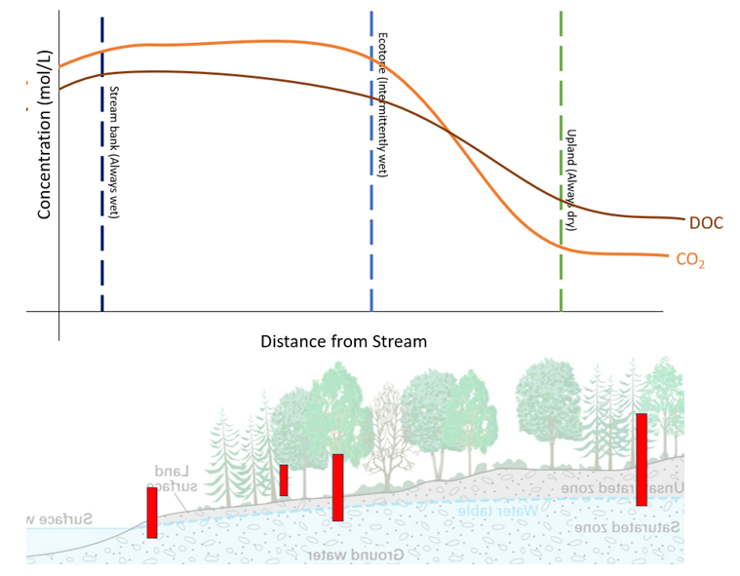
FIGURE 2. Visual aid for hypothesis 1. Red rectangles are proposed well locations, and the above line graph hypothesizes DOC and CO2 concentrations within each well’s zone. Due to the river corridor’s (RC) tremendous carbon storage potential, as water moves laterally towards the stream, the concentration of C increases before discharging to the stream.

Methods:
Study Site:
The Bradford Forest tract, spanning 27,000 acres in Bradford County, Florida, encompasses a contiguous pine flatwoods landscape situated within the Hawthorne Formation. This formation comprises a substantial clay bed that confines the principal aquifer stretching from North Florida to South Carolina (Hensley & Cohen, 2017). Characterized by low-relief topography, the area is densely packed with depressional basin wetlands, typical of North Florida flatwoods. These wetlands, both isolated and riparian, are predominantly dominated by cypress domes and wiregrass.
Streams within the Bradford Forest area exhibit typical characteristics of blackwater systems: they are tannic, rich in dissolved organic carbon (DOC), with low pH levels and high concentrations of carbon dioxide (CO2). These streams, both permanent and intermittent, drain the landscape before discharging into either the Sampson River (at the southern extent) or Sampson Lake (at the northern extent). The land is primarily managed for silviculture and is owned entirely by the Rayonier Corporation, with only a few residential homes and businesses present.
For my research project, I will observe three streams from three distinct basins, each representing a gradient of wetland-area coverage (FIGURE 3). Alongside these streams, I will also observe the intermittently connected wetlands to estimate their carbon (C) contribution during periods of high discharge.
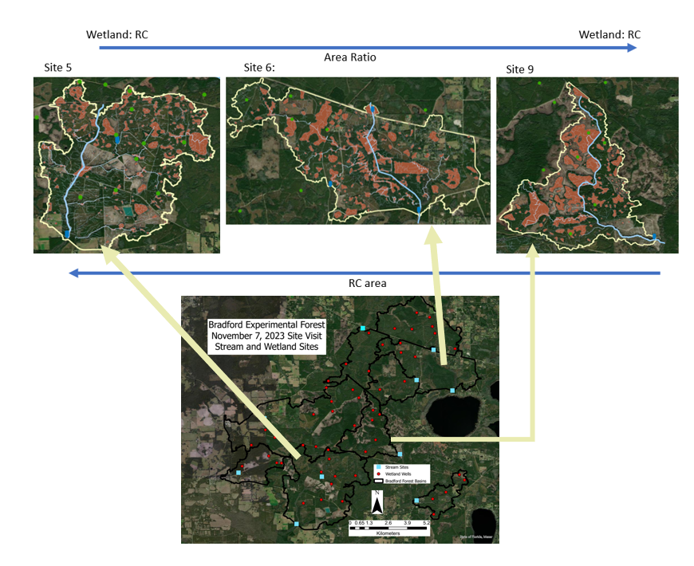
FIGURE 3. A map depicting site locations and the surrounding landscape. The Bradford Forest tract, spanning 27,000 acres in Bradford County, Florida, encompasses a contiguous pine flatwoods landscape situated within the Hawthorne Formation. Characterized by low-relief topography, the area is densely packed with depressional basin wetlands, typical of North Florida flatwoods.

Water Sampling and High-Frequency Observations:
Each stream in the Bradford Forest tract will be equipped with a sensor package for tracking stream chemistry at hourly intervals. This package includes sensors for dissolved oxygen (DO), pH, CO2, and conductivity (SpC), along with two pressure transducers (PT) - one deployed in ambient air and the other in the water column. Groundwater wells will be strategically installed across the river corridor (RC) elevation and microsites, including locations on the stream bank, in the uplands, between the uplands and the stream bank, and in intermittent flow paths and depressions, if present.
During each monthly field visit, a roving pH and CO2 sensor will be placed in the wells to detect groundwater concentrations for point-readings. Additionally, water table depth will be measured using a water level meter. Water samples for DIC, DOC, particulate organic carbon (POC), and fluorescent dissolved organic matter (FDOM) will be collected from the streams and wells. During periods of high discharge, FDOM, DIC, DOC, and POC samples will be taken from intermittent flow paths and their associated wetlands. DOC analysis will be conducted using the Shimadzu TOC-L analyzer, while DIC concentrations will be analyzed on the Shimadzu and through titrations for alkalinity. POC concentrations will be determined using dry-weight and ash-free dry weight methods. FDOM samples will be analyzed using the HORIBA Aqualog. The PARAFAC model, akin to principal component analysis, will be employed to differentiate wetland, stream, and wetland C signatures, allowing estimation of upland and lowland contributions to C dynamics.
Discharge Estimates
The estimation of RC lateral discharge will use methods adapted from Kirk and Cohen (2020) and involves applying concepts and filtering techniques from Kalbus et al. (2016) and Leopold & Maddock (1953). This approach utilizes mass balance principles to divide spring discharge into low discharge (baseflow) and high discharge (surface run-off). Digital elevation model (DEM) data will be utilized to estimate the upslope contributing area (UCA) for each spring. This UCA represents the area of land that contributes water to the spring's discharge. From here, the interpolation of lateral discharge is achieved by multiplying the UCA by the baseflow.
Data synthesis
To compare RC influence across confined and unconfined aquifer units, available data on C concentrations (including IC and OC), discharge and DEMs from 2014 to the present will be collected from the literature and the Water Quality Portal (WQP). Sites with a minimum of ten water sample collections will be retained for analysis.

Statistical Analysis
To assess whether RC C-contributions to stream C vary across different wetland area coverages and discharge levels, linear regression analysis will be employed to evaluate the strength of correlation. To test whether RC contributions significantly differ between confined and unconfined basins, as well as to assess whether RC contributes more to stream C than wetlands, analysis of variance (ANOVA) tests will be conducted. ANOVA tests will allow for the comparison of mean C-stream contributions between confined and unconfined basins, as well as between RC contributions and wetland contributions, providing insights into the relative importance of RC in contributing to stream C compared to wetlands. By employing these statistical analyses, the study aims to interrogate the factors influencing RC C-stream contributions and assess their significance in comparison to wetland contributions, expanding the of C dynamics within the study area.
Conclusion:
A widely adopted best management practice for water conservation in North Florida is the water credits program. Simply, this program compensates forest and agriculture landowners for conserving water. For instance, pine stands, typical of the North Florida flatwoods, heavily rely on groundwater. Paying timber harvesters to reduce planting without sacrificing profit benefits both pine plantations and groundwater preservation.
Water management districts are now proposing a similar program for carbon (C) storage, known as carbon credits. The flatwoods of North Florida, characterized by their low-relief topography and confined aquifer, provide an ideal landscape for C storage due to their abundance of wetlands. Despite strong legal incentives in Florida to preserve wetlands and natural streams, forest landowners often clear ecotonal zones, such as riparian wetlands, in pursuit of greater profits- the more land cleared for pine stands, the greater the profit. The proposed carbon credit program has the potential to reverse this trend. By compensating forest landowners for stored C, the program promotes wetland conservation, offsets CO2 emissions, and benefits foresters.
However, there are significant knowledge gaps concerning C cycling in low-relief, wetland-rich plantation landscapes that need to be addressed. These include understanding river corridor C storage capacity and the overall influence of wetlands on stream CO2 emissions. Through my research, I aim to shed light on the often-overlooked role of riparian wetlands in inland water systems and provide insights into managing low-relief, wetland-rich landscapes for enhanced C storage.

References:
Abril, G., & Borges, A. V. (2019). Ideas and perspectives: Carbon leaks from flooded land: Do we need to replumb the inland water active pipe? Biogeosciences, 16(3), 769–784. https://doi.org/10.5194/bg-16-769-2019
Battin, T. J., Luyssaert, S., Kaplan, L. A., Aufdenkampe, A. K., Richter, A., & Tranvik, L. J. (2009). The boundless carbon cycle. In Nature Geoscience (Vol. 2, Issue 9, pp. 598–600). https://doi.org/10.1038/ngeo618
Casson, N. J., Eimers, M. C., Watmough, S. A., & Richardson, M. C. (2019). The role of wetland coverage within the near-stream zone in predicting of seasonal stream export chemistry from forested headwater catchments. Hydrological Processes, 33(10), 1465–1475. https://doi.org/10.1002/hyp.13413
Cole, J. J., Prairie, Y. T., Caraco, N. F., McDowell, W. H., Tranvik, L. J., Striegl, R. G., Duarte, C. M., Kortelainen, P., Downing, J. A., Middelburg, J. J., & Melack, J. (2007). Plumbing the global carbon cycle: Integrating inland waters into the terrestrial carbon budget. Ecosystems, 10(1), 171–184. https://doi.org/10.1007/s10021-006-9013-8
Drake, T. W., Raymond, P. A., & Spencer, R. G. M. (2018). Terrestrial carbon inputs to inland waters: A current synthesis of estimates and uncertainty. In Limnology And Oceanography Letters (Vol. 3, Issue 3, pp. 132–142). John Wiley and Sons Inc. https://doi.org/10.1002/lol2.10055
Evenson, G. R., Golden, H. E., Lane, C. R., McLaughlin, D. L., & D’Amico, E. (2018). Depressional wetlands affect watershed hydrological, biogeochemical, and ecological functions. Ecological Applications, 28(4), 953–966. https://doi.org/10.1002/eap.1701
Harvey, J., & Gooseff, M. (2015). River corridor science: Hydrologic exchange and ecological consequences from bedforms to basins. In Water Resources Research (Vol. 51, Issue 9, pp. 6893–6922). Blackwell Publishing Ltd. https://doi.org/10.1002/2015WR017617
Hensley, R. T., & Cohen, M. J. (2017). Flow reversals as a driver of ecosystem transition in Florida’s springs. Freshwater Science, 36(1), 14–25. https://doi.org/10.1086/690558
Hosen, J. D., Armstrong, A. W., & Palmer, M. A. (2018). Dissolved organic matter variations in coastal plain wetland watersheds: The integrated role of hydrological connectivity, land use, and seasonality. Hydrological Processes, 32(11), 1664–1681. https://doi.org/10.1002/hyp.11519
Hotchkiss, E. R., Hall, R. O., Sponseller, R. A., Butman, D., Klaminder, J., Laudon, H., Rosvall, M., & Karlsson, J. (2015). Sources of and processes controlling CO2emissions change with the size of streams and rivers. Nature Geoscience, 8(9), 696–699. https://doi.org/10.1038/ngeo2507
Kirk, L. (2020). METABOLISM IN SUBTROPICAL LOWLAND RIVERS.
Kirk, L., & Cohen, M. J. (2023). River Corridor Sources Dominate CO2 Emissions From a Lowland River Network. Journal of Geophysical Research: Biogeosciences, 128(1). https://doi.org/10.1029/2022JG006954
Ledesma, J. L. J., Grabs, T., Bishop, K. H., Schiff, S. L., & Köhler, S. J. (2015). Potential for long-term transfer of dissolved organic carbon from riparian zones to streams in boreal catchments. Global Change Biology, 21(8), 2963–2979. https://doi.org/10.1111/gcb.12872
Ledesma, J. L. J., Kothawala, D. N., Bastviken, P., Maehder, S., Grabs, T., & Futter, M. N. (2018). Stream Dissolved Organic Matter Composition Reflects the Riparian Zone, Not Upslope Soils in Boreal Forest Headwaters. Water Resources Research, 54(6), 3896–3912. https://doi.org/10.1029/2017WR021793
Leibowitz, S. G., Wigington, P. J., Schofield, K. A., Alexander, L. C., Vanderhoof, M. K., & Golden, H. E. (2018). Connectivity of Streams and Wetlands to Downstream Waters: An Integrated Systems Framework. Journal of the American Water Resources Association, 54(2), 298–322. https://doi.org/10.1111/1752-1688.12631
Li, J., Jiang, M., Pei, J., Fang, C., Li, B., & Nie, M. (2023). Convergence of carbon sink magnitude and water table depth in global wetlands. In Ecology Letters (Vol. 26, Issue 5, pp. 797–804). John Wiley and Sons Inc. https://doi.org/10.1111/ele.14199
McLaughlin, D. L., Kaplan, D. A., & Cohen, M. J. (2014). A significant nexus: Geographically isolated wetlands influence landscape hydrology. Water Resources Research, 50(9), 7153–7166. https://doi.org/10.1002/2013WR015002
Mitsch, W. J., Bernal, B., Nahlik, A. M., Mander, Ü., Zhang, L., Anderson, C. J., Jørgensen, S. E., & Brix, H. (2013). Wetlands, carbon, and climate change. Landscape Ecology, 28(4), 583–597. https://doi.org/10.1007/s10980-012-9758-8
Moustapha, M., Deirmendjian, L., Sebag, D., Braun, J. J., Audry, S., Ateba Bessa, H., Adatte, T., Causserand, C., Adamou, I., Ngounou Ngatcha, B., & Guérin, F. (2022). Partitioning carbon sources between wetland and well-drained ecosystems to a tropical first-order stream - implications for carbon cycling at the watershed scale (Nyong, Cameroon). Biogeosciences, 19(1), 137–163. https://doi.org/10.5194/bg-19-137-2022
Raymond, P. A., Hartmann, J., Lauerwald, R., Sobek, S., McDonald, C., Hoover, M., Butman, D., Striegl, R., Mayorga, E., Humborg, C., Kortelainen, P., Dürr, H., Meybeck, M., Ciais, P., & Guth, P. (2013). Global carbon dioxide emissions from inland waters. Nature, 503(7476), 355–359. https://doi.org/10.1038/nature12760
Regnier, P., Resplandy, L., Najjar, R. G., & Ciais, P. (2022). The land-to-ocean loops of the global carbon cycle. In Nature (Vol. 603, Issue 7901, pp. 401–410). Nature Research. https://doi.org/10.1038/s41586-021-04339-9
Solano, V., Duvert, C., Hutley, L. B., Cendón, D. I., Maher, D. T., & Birkel, C. (2024). Seasonal Wetlands Make a Relatively Limited Contribution to the Dissolved Carbon Pool of a Lowland Headwater Tropical Stream. Journal of Geophysical Research: Biogeosciences, 129(2). https://doi.org/10.1029/2023JG007556
Vázquez, E., Romaní, A. M., Sabater, F., & Butturini, A. (2007). Effects of the dry-wet hydrological shift on dissolved organic carbon dynamics and fate across stream-riparian interface in a Mediterranean catchment. Ecosystems, 10(2), 239–251. https://doi.org/10.1007/s10021-007-9016-0
Vlek, P. L. G. (2014). An Appraisal of Global Wetland Area and Its Organic Carbon Stock. https://www.researchgate.net/publication/255613109
Wohl, E., Hall, R. O., Lininger, K. B., Sutfin, N. A., & Walters, D. M. (2017). Carbon dynamics of river corridors and the effects of human alterations. Ecological Monographs, 87(3), 379–409. https://doi.org/10.1002/ecm.1261

